**It is hypothesized that one of the effects of covert attention is to change the bandwidth of spatial frequency and/or orientation channels.**

1. **Given that arguably the function of attention is to improve discrimination at the attended location, would it be in the observer's best interest to broaden or to narrow spatial frequency and/or orientation bandwidths at the attended location? Justify your choice with reference to a model of a particular task that would predict improved performance with the hypothesized change in bandwidth.**
2. **Design a psychophysical experiment to test this hypothesis:** 
   1. **Describe the experimental design including what kind of attention (spatial or feature, endogenous or exogenous) you are manipulating and how you are doing so, the particular stimuli, task, and procedure.**
   2. **Explain how you will analyze the data.**
   3. **Describe the potential outcomes and how they will either prove or disprove the hypothesis.**
   4. **Include description of relevant control experiments that indicate you can measure a bandwidth and you have changed performance with your attentional manipulation.**
3. **Extra credit. Matlab simulations are welcome (you could generate a simulated data set assuming that the hypothesis is true, another simulated data set assuming that it is false, and walk through the analysis, results, and interpretation for each).**

**Question 1:**

Assuming that covert attention can improve discriminability at attended locations, observers would prefer **narrowing both spatial frequency and orientation bandwidth** in order to achieve better performance (by reducing interference from adjacent frequencies or tilting angels). Based on the signal detection theory, improved signal-to-noise ratio enhances detection and discrimination. Therefore, narrowing the bandwidth should effectively increase signal-to-noise ratio since it decreases possible noises.

In Yeshurun and Carrasco (1998)’s study, they proposed that covert attention can enhance performance where the improvement could be attributed to signal enhancement rather than just noise reduction or changes in decisional criteria. Their study demonstrates that attention was found to improve performance at peripheral vision areas, where spatial resolution is typically lower. This implies that attention can boost spatial resolution where it is insufficient. Conversely, they also suggested that attention can impaired performance at central retinal locations. Given that central vision already has high spatial resolution, Yeshurun and Carrasco (1998) concluded that the impairment was due to attention excessively enhancing spatial resolution in these areas. In conclusion, this study suggested that attention doesn't just selectively filter visual information but actively enhances the quality of the signal. However, this enhancement is not uniformly beneficial across different parts of the visual field.

(Figure 1)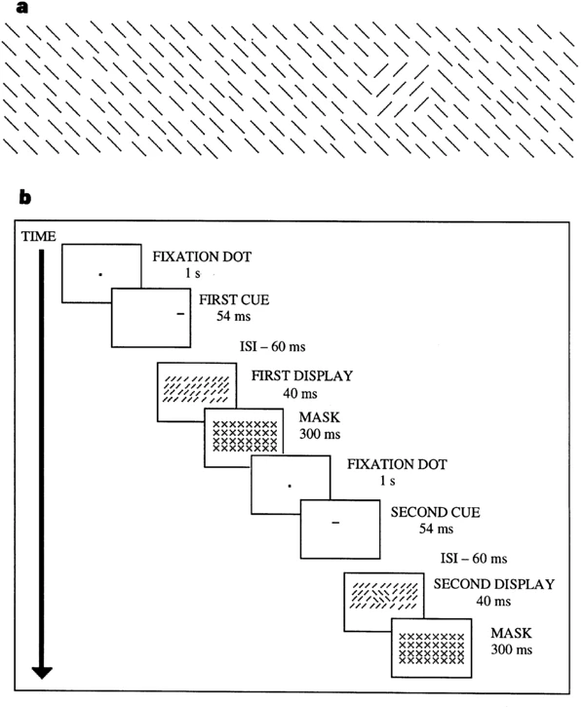

For their experimental design, shown by Figure 1, Yeshurun and Carrasco (1998) adopted a texture segregation task, with displaying stimuli at different visual field locations (central v.s. Peripheral, by varying eccentricities). To present covert spatial attention, participants are asked to fixate but allocate their attention towards specific locations indicated by attentional cues.

**Question 2**

**Hypothesis** To begin with, the research question would be: Given that covert attention improves discriminability at attended location, whether a broader or narrower bandwidth of spatial frequency/orientation can result in a higher response gain. The hypothesis would be: Narrowing bandwidth of spatial frequency/orientation can result in higher performance. The null hypothesis would be: Narrowing bandwidth of spatial frequency/orientation can not result in higher performance.

**Tasks** Here, two experiments testing covert endogenous and exogenous attention respectively will be performed.

Experiment A (Figure 2): Covert endogenous attention 2AFC task

(Figure 2)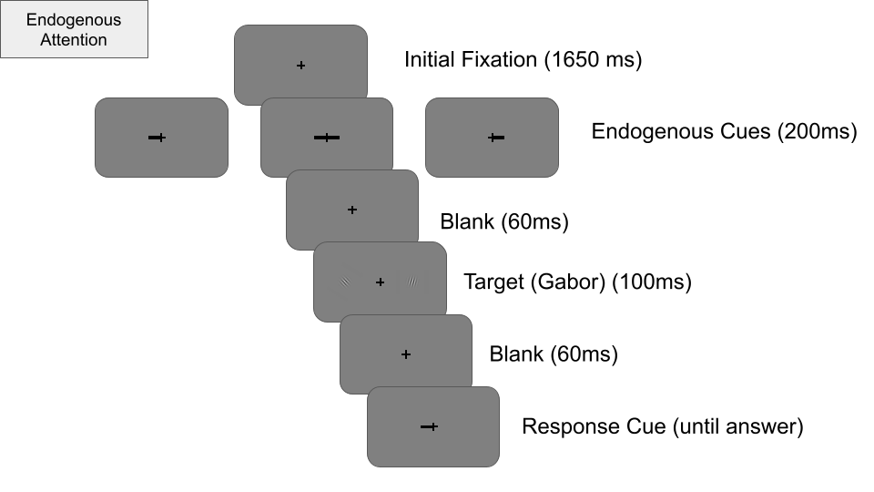

After an initial fixation window for 1650ms, a peripheral (valid/invalid) or distributed (neutral) endogenous cue will be presented for 200ms. Participants will be instructed to attend to the location indicated by the endogenous cue (e.g. if the endogenous cue points left, then subjects attend the left location). All cues will be uninformative with equal likelihood. After a 60ms blank window, two Gabor will be presented on the screen for 100ms. The Gabor size was adjusted according to the Cortical Magnification Factor [M = M0(1+0.42E+0.000055E3)-1]98. The Gabors are scaled to match a cortical magnification of 2° wide at 4° eccentricity. After presentation of targets, a blank window will be presented for 60ms and follows up a response cue (blank line, length 0.75°) (Hanning et al., 2023). Participants will be asked to report whether the Gabor at cued location tilts left or right.

For stimulus, there will be two sub experiments:  
 Experiment A.1 Covert endogenous attention and spatial frequency

Gabor grating (spatial frequency) of both stimuli will vary between 1cpd to 7cpd (7 levels), with equal likelihoods. The tilt angle of each Gabor is fixed and obtained from a tilt angle thresholding session (for left hemifield and right hemifield separately).

Experiment A.2 Covert endogenous attention and orientation

Gabor grating is fixed and obtained from a spatial frequency thresholding session (for left hemifield and right hemifield separately). Tilt angle of each Gabor varies between -90°– +90° ( 7 intervals) relative to vertical.

Experiment B (Figure 3): Covert exogenous attention 2AFC task

(Figure 3)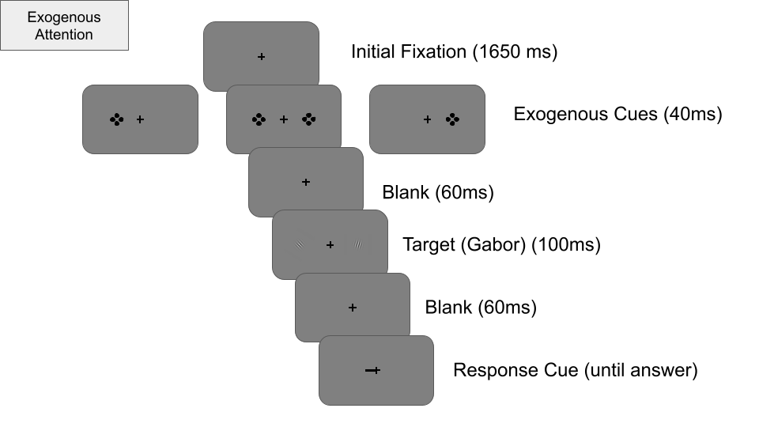

At the beginning, there will be an 1650ms initial fixation window. The exogenous cue consists of 4 black dots ( 2 above and 2 below, 2 left and 2 right), each dot is 0.1 dva wide and 1 dva away from the Gabor edge, with a separation by 1° from the Gabors (Fernández & Carrasco, 2020). A peripheral (valid/invalid) or distributed (neutral) exogenous cue will be presented for 40ms. Participants will be instructed to ignore the exogenous cue. All cues will be uninformative with equal likelihood. After a 60ms blank window, two Gabor will be presented on the screen for 100ms. The Gabor size was adjusted according to the Cortical Magnification Factor [M = M0(1+0.42E+0.000055E3)-1]98. The Gabors are scaled to match a cortical magnification of 2° wide at 4° eccentricity. After presentation of targets, a blank window will be presented for 60ms and follows up a response cue (blank line, length 0.75°). Participants will be asked to report whether the Gabor at cued location tilts left or right.

For stimulus, there will be two sub experiments:  
 Experiment B.1 Covert exogenous attention and spatial frequency

Gabor grating (spatial frequency) of both stimuli will vary between 1cpd to 7cpd (7 levels), with equal likelihoods. The tilt angle of each Gabor is fixed and obtained from a tilt angle thresholding session (for left hemifield and right hemifield separately).

Experiment B.2 Covert exogenous attention and orientation

Gabor grating is fixed and obtained from a spatial frequency thresholding session (for left hemifield and right hemifield separately). Tilt angle of each Gabor varies between -90°– +90° ( 7 intervals) relative to vertical.

**Attentional conditions** In above two studies, there are overall three attentional conditions: for valid condition, the location of endogenous/exogenous cue matches the location of response cue (e.g. they both appears on left side); for invalid condition, the location of endogenous/exogenous cue does not match the location of response cue (e.g. endogenous/exogenous cue appears on left side but response cue appears on right side); for neutral condition, the endogenous/exogenous cue appears on both sides.

**Procedure** Observers will be set-up in a dark room and stabilize their head on a chin and forehead rest. The digital representation of the experiment will be at 57cm distance on a gamma-linearized ViewPixx/EEG LCD monitor, with spatial resolution of 1920x1080 pixels and refresh rate of 120Hz (Fernández & Carrasco, 2020; Hanning et al., 2023). Covert attention is ensured by adopting eye-tracker (EyeLinke). Participants will be asked to complete a 1 session spatial frequency/tilt angle thresholding first. Following, they will be asked to attend 3 more sessions for the main experiment.

**Statistical analysis** The task performance, with index by sensitivity (d-prime; d ’= z(hit rate) - z(false alarm rate)), will be measured as a function of spatial frequency/orientation. For hits, it has been defined as when gabor tilted left and response reported left; whereas for false alarm, it has been defined as when gabor tilted right but response reported left. After obtaining the d-prime, the psychometric function of Weibull can be fitted for different conditions and a response gain/loss can be seen.

|  |  |  |
| --- | --- | --- |
|  | **Target Tilt Left** | **Target Tilt Right** |
| **Report Left** | Hit | False Alarm |
| **Report Right** | Miss | Correct Rejection |

Finally, a two-way [attentional state (valid/invalid/neutral) X Spatial frequency/Orientation] repeated-measures ANOVA will be performed to assess statistical significance, and followed by post-hoc comparisons (if applicable).

**Results** see Appendix Simulation. From the generation, it can be concluded that covert attention does enhance overall performance (valid > Neutral > invalid). Moreover, as spatial frequency/orientation bandwidth increase, the d-prime decrease. The peak of d-prime across condition tend to be around spatial frequency 4/5. Therefore, the simulation result support the hypothesis, where narrowing bandwidth of spatial frequency/orientation can result in higher performance, and thus reject the null hypothesis.

**References**

Fernández, A., & Carrasco, M. (2020). Extinguishing Exogenous Attention via Transcranial Magnetic Stimulation. *Current biology : CB, 30*(20), 4078–4084.e3. <https://doi.org/10.1016/j.cub.2020.07.068>

Hanning, N.M., Fernández, A. & Carrasco, M. Dissociable roles of human frontal eye fields and early visual cortex in presaccadic attention. *Nat Commun 14, 5381* (2023). https://doi.org/10.1038/s41467-023-40678-z

Yeshurun, Y., & Carrasco, M. (1998). Attention improves or impairs visual performance by enhancing spatial resolution. *Nature, 396*(6706), 72–75. https://doi.org/10.1038/23936